SISTEM KONTROL DAN MONITORING GERBANG OTOMATIS

BERBASIS SMARTPHONE

PROYEK AKHIR

Diajukan Untuk Memenuhi Sebagian dari Syarat Memperoleh Gelar Ahli Madya Departemen Pendidikan Teknik Elektro

Oleh :

Rifaldy Fauzy Ridwan

E5231.1602123

PROGRAM STUDI D3 TEKNIK ELEKTRO
DEPARTEMEN PENDIDIKAN TEKNIK ELEKTRO
FAKULTAS PENDIDIKAN TEKNOLOGI DAN KEJURUAN
UNIVERSITAS PENDIDIKAN INDONESIA
BANDUNG
2019

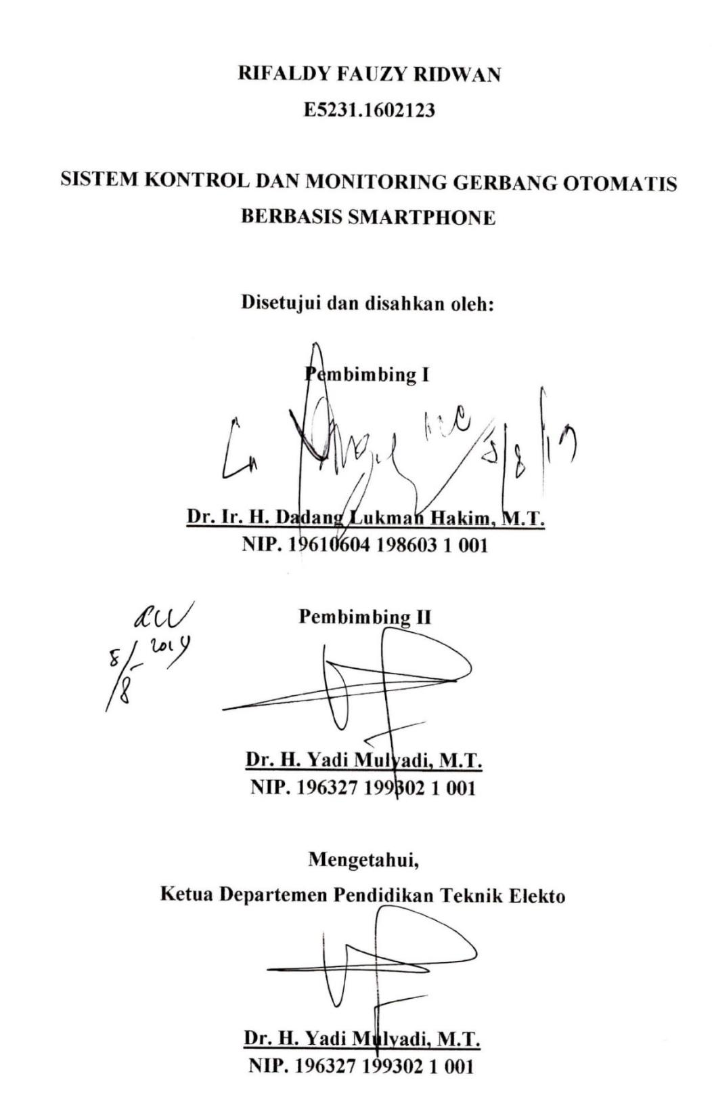

i

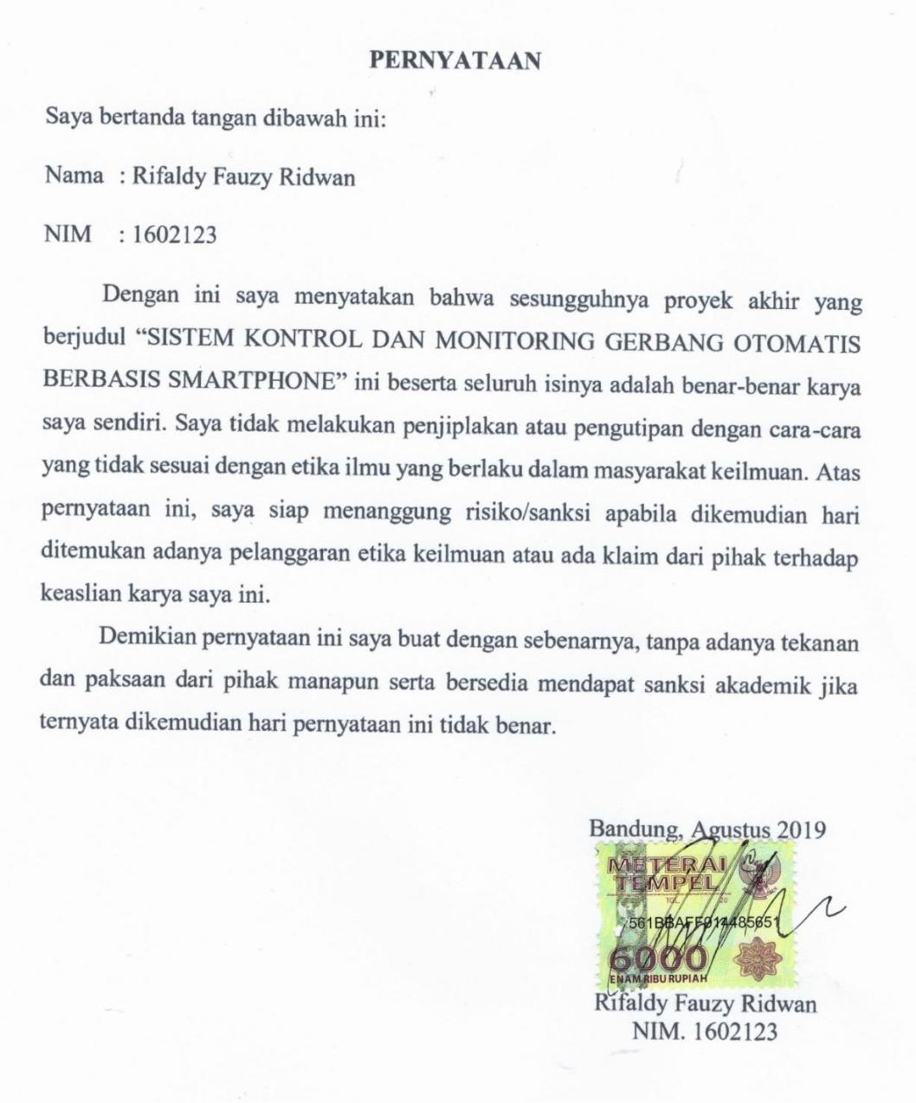

ABSTRAK

Perkembangan zaman sekarang semakin meningkat, manusia mengharapkan sebuah alat atau teknologi yang dapat membantu pekerjaan manusia, sehingga teknologi menjadi kebutuhan bagi manusia. Tugas akhir ini membuat sebuah hasil penelitian tentang sistem kontrol dan monitoring gerbang otomatis berbasis NodeMCU dan sistem smartphone. Pembuatan alat dilakukan sebagai salah satu usaha dalam kemajuan teknologi untuk memberikan kemudahan dan kenyamanan melalui sistem otomasi pada rumah berupa gerbang otomatis. Komponen yang digunakan untuk perancangan sistem adalah mikrokontroler NodeMCU V3, sensor proximity, motor servo, limit switch, power supply dan smartphone, sedangkan pada perancangan software menggunakan Arduino IDE dan Blynk. Berdasarkan hasil pengukuran dan pengujian, sistem pada alat yang dibuat mampu membuka dan menutup pintu gerbang secara otomatis pada jarak maksimum 44 meter dengan waktu respon maksimum 1 detik dalam keadaan ruang terbuka.

v

ABSTRACT

Today's development is increasing, humans expect a tool or technology that can help human work, so technology becomes a necessity for humans. This final project creates a result of research on NodeMCU-based automatic gate control and monitoring systems and smartphone systems. The making of tools is done as one of the efforts in advancing technology to provide convenience and comfort through an automated system in the home in the form of automatic gates. The components used for system design are the NodeMCU V3 microcontroller, proximity sensors, servo motors, limit switches, power supply and smartphones, while the software design uses Arduino IDE and Blynk. Based on the results of measurements and testing, the system on the device made is able to open and close the gate automatically at a maximum distance of 44 meters with a maximum response time of 1 second in the state of open space.

vi

 |  | DAFTAR ISI
LEMBAR PENGESAHAN ................................................................................... |  |  | i
LEMBAR PERNYATAAN .................................................................................. |  |  | ii
KATA PENGANTAR .......................................................................................... |  |  | iii
ABSTRAK |  | ............................................................................................................. | v
DAFTAR ISI ........................................................................................................ |  |  | vii
DAFTAR GAMBAR ............................................................................................. |  |  | x
DAFTAR TABEL................................................................................................ |  |  | xii
BAB I ..................................................................................................................... |  |  | 1
PENDAHULUAN .................................................................................................. |  |  | 1
1.1 | Latar Belakang.......................................................................................... |  | 1
1.2 | Rumusan Masalah .................................................................................... |  | 2
1.3 | Batasan Masalah ....................................................................................... |  | 2
1.4 | Tujuan ....................................................................................................... |  | 3
1.5 | Manfaat ..................................................................................................... |  | 3
1.6 | Sistematika Penulisan ............................................................................... |  | 3
BAB II .................................................................................................................... |  |  | 5
LANDASAN TEORI ............................................................................................. |  |  | 5
2.1 | Pengertian Gerbang .................................................................................. |  | 5
2.1.1 |  | Gerbang Otomatis ............................................................................. | 5
2.1.2Sistem Kontrol Gerbang Otomatis .................................................... |  |  | 6
2.2 | IoT (Internet of Things) ............................................................................ |  | 7
2.3 | Sistem Mikrokontroler.............................................................................. |  | 8
2.4 | Smartphone ............................................................................................... |  | 9
2.5 | Komponen Pada Sistem Gerbang Otomatis ............................................. |  | 9
2.5.1 |  | NodeMCU ......................................................................................... | 9

vii

2.5.2 |  | Limit Switch .................................................................................... | 11
2.5.3 |  | Motor Servo .................................................................................... | 13
2.5.4 |  | PCB (Printed Circuit Board) ........................................................... | 16
2.5.5 |  | Proximity Sensor E18-D80NK ....................................................... | 19
2.6 | Software Pada Sistem Gerbang Otomatis............................................... |  | 20
2.6.1 |  | Arduino IDE .................................................................................... | 20
2.6.2 |  | Software Blynk................................................................................ | 21
BAB III | ................................................................................................................. |  | 24
METODOLOGI PENELITIAN ........................................................................ |  |  | 24
3.1 | Tahap Penelitian ..................................................................................... |  | 24
3.2 | Waktu dan Tempat Kegiatan .................................................................. |  | 25
3.3 | Ruang Lingkup Kegiatan ........................................................................ |  | 25
3.4 | Alat dan Bahan ....................................................................................... |  | 25
3.5 | Perancangan Alat .................................................................................... |  | 26
3.5.1 |  | Perancangan Sistem ........................................................................ | 26
3.5.2 |  | Perancangan Mekanik ..................................................................... | 27
3.5.1 |  | Perancangan Box............................................................................. | 27
3.5.4 |  | Perancangan Elektronika ................................................................. | 28
3.5.5 |  | Perancangan Prototype .................................................................... | 32
3.5.6 |  | Perancangan Software ..................................................................... | 32
BAB IV | ................................................................................................................. |  | 38
PENGUJIAN ALAT ........................................................................................... |  |  | 38
4.1 | Pengujian Sensor Proximity ................................................................... |  | 38
4.2 | Pengujian Koneksi Wi-Fi ....................................................................... |  | 38
4.3 | Pengujian Keseluruhan ........................................................................... |  | 40
BAB V ..................................................................................................................... |  |  | 43

viii

SIMPULAN, IMPLIKASI DAN REKOMENDASI 43

5.1 Simpulan 43

5.2 IMPLIKASI 43

5.3 REKOMENDASI 43

DAFTAR PUSTAKA 45

LAMPIRAN .............................................................................................................

ix

DAFTAR PUSTAKA

Franseda, A., Dirgantoro, B., & Saputra, R. E. (2017). Implementasi Sistem Kendali Otomatis Pada Pintu Gerbang Parkir Berbasis Mikrokontroler. e-Proceeding of Engineering Vol.4 No.1, 372-373.

Gerbang. (2017, November 26). (online). Diambil kembali dari Wikipedia:

https://id.wikipedia.org/wiki/Gerbang. diakses[tgl.20 Juli 2019]

Kho, D. (2019). Pengertian PCB (Printed Circuit Board) dan Jenis-jenis PCB.

(online). Diambil kembali dari teknik elektronika: https://teknikelektronika.com/ pengertian-pcb-printed-circuit-board-jenis-jenis-pcb/. diakses[tgl.20 Juli 2019]

Muzawi, R., Efendi, Y., & Agustin, W. (2018). Sistem Pengendalian Lampu Berbasis Web dan Mobile . Jurnal STMIK Amik Riau, 3.

Proximity Switch E18-D80NK Infrared Sensor Obstacle Avoidance 3-80cm. (2012). (online). Diambil kembali dari Buaya Instrumen: http://buaya-instrument.com/sensor-proximity-switch-e18-d80nk-infrared-obstacle-avoidance-3-80cm-1002000008.html. diakses[tgl.20 Juli 2019]

Suresh, P., Daniel, V., & Aswathy, R. (2014). A state of the art review on the Internet of Things (IoT) history, technology and fields of deployment. International Conference on Science Engineering and Management Research (ICSEMR).

Dermanto, T. (2014). Desain Sistem Kontrol.

Syahrul. (2012). Dasar – dasar Mikrokontroler ATMega 16. Bandung: Informatika.

Williams, & Sawyer. (2011). “Using Information Technology: A Practical Introduction to Computers & Communications. (9th edition). New York: McGraw Hill.

45

